

**Resume Parsing System**

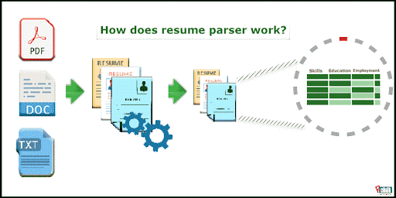

**Project done by:**

**Guided by:**  P. Radha devi (192211652)

MONIKA MAM S. Vaishnavi (192211575)

**Introduction to Resume Parsing**

Resume parsing is a powerful technology that automates the process of extracting and organizing key information from job applicants' resumes. By leveraging natural language processing and machine learning algorithms, resume parsing systems are able to quickly and accurately identify and extract critical details such as an applicant's work history, skills, education, and contact information. This streamlines the hiring process, enabling recruiters and HR professionals to more efficiently review and evaluate candidates.

**Abstract:**

Resume parsing is a highly important process for HR departments and recruiters looking to streamline their hiring process. By converting a resume into structured data, it allows for easy organization and quick searchability for specific qualifications and skills. Benefits of Automated Resume Parsing

**Time Savings**

Resume parsing eliminates the need for manual data entry, allowing hiring teams to focus on evaluating candidates rather than transcribing information.

**Improved Accuracy**

Automated systems can extract data with a high degree of precision, minimizing errors that can occur with manual review.

**Consistent Evaluation**

Resume parsing applies standardized criteria to evaluate all applicants, ensuring a fair and impartial screening process.

**Enhanced Insights**

The structured data generated by resume parsing enables more robust analytics and reporting, providing valuable insights to improve hiring strategies.

**Materials and methods of a Resume Parsing System**

**Data Extraction**

Advanced natural language processing algorithms identify and extract key information from resumes, such as work history, education, skills, and contact details.

**Categorization**

Extracted data is categorized and organized into a standardized format, enabling efficient storage and retrieval in the applicant tracking system.

**Customization**

Robust configuration options allow the resume parsing system to be tailored to an organization's specific needs and hiring criteria.

**Parsing Algorithms and Techniques**

"The key to effective resume parsing lies in the underlying algorithms and techniques used to extract and interpret the data."

Resume parsing systems employ a variety of advanced natural language processing (NLP) techniques to analyse resumes, including named entity recognition, semantic analysis, and machine learning. These algorithms are trained on vast datasets of resumes to identify and categorize relevant information with a high degree of accuracy. Continued research and development in areas like deep learning and neural networks are further enhancing the capabilities of resume parsing systems.

**Discussion:**

Once the relevant information has been identified within a resume, the next step is to normalize and standardize the data. This involves converting the extracted details into a consistent, structured format that can be easily integrated into the applicant tracking system. For example, job titles may be mapped to a common taxonomy, and dates of employment may be converted to a standard date format. Sophisticated parsing algorithms can also handle variations in resume formatting and content to ensure reliable and accurate data extraction.

**Integration with Applicant Tracking Systems**

**Data Transfer**

The resume parsing system seamlessly transfers the extracted and normalized applicant data directly into the organization's applicant tracking system (ATS), eliminating the need for manual data entry.

**Automated Workflows**

Resume parsing can be integrated with the ATS to trigger automated workflows, such as sending candidate notifications, scheduling interviews, and updating the status of applications.

**Reporting and Analytics**

The structured data provided by resume parsing enables robust reporting and analytics capabilities within the ATS, providing valuable insights to improve hiring practices.

**Result and conclusion:**

As with any technology that handles sensitive personal information, resume parsing systems must adhere to strict compliance and privacy regulations. This includes ensuring the secure storage and transmission of applicant data, as well as obtaining proper consent for data processing. Robust access controls, encryption, and audit trails are essential to protect the privacy of job applicants. Additionally, resume parsing systems should be regularly reviewed and updated to maintain compliance with evolving legal and regulatory requirements.

**Scope:**

Maintaining a high-performing resume parsing system requires ongoing refinement and optimization. This includes regularly reviewing and updating the underlying algorithms, expanding the system's knowledge base, and incorporating feedback from end-users. Continuous monitoring and analysis of the parsing results can help identify areas for improvement, such as enhancing the accuracy of data extraction or streamlining integration with the applicant tracking system. By embracing a culture of continuous improvement, organizations can ensure their resume parsing technology remains effective and efficient in supporting their hiring efforts.

**Graph:** 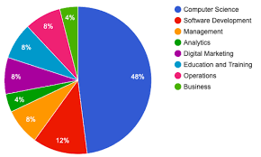

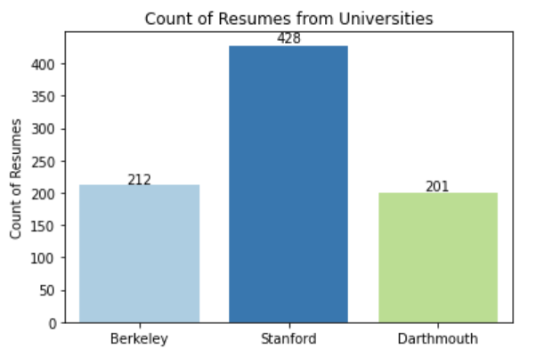

**References:**

Craddock, Hillary A., Younes Rjoub, Kristal Jones, Clive Lipchin, and Amy R. Sapkota. 2021. “Perceptions on the Use of Recycled Water for Produce Irrigation and Household Tasks: A Comparison between Israeli and Palestinian Consumers.” *Journal of Environmental Management* 297 (113234): 113234.

Dayton, E. A., and N. T. Basta. 2005. “Use of Drinking Water Treatment Residuals as a Potential Best Management Practice to Reduce Phosphorus Risk Index Scores.” *Journal of Environmental Quality* 34 (6): 2112–17.

Fall, Greg, David Kitzmiller, Sandra Pavlovic, Ziya Zhang, Nathan Patrick, Michael St. Laurent, Carl Trypaluk, Wanru Wu, and Dennis Miller. 2023. “The Office of Water Prediction’s Analysis of Record for Calibration, Version 1.1: Dataset Description and Precipitation Evaluation.” *Journal of the American Water Resources Association*, July. https://doi.org/10.1111/1752-1688.13143.

Hidayati, Farida, Doctoral Program of Public Health, Faculty of Medicine, Sebelas Maret University, Surakarta 57126, Indonesia, Mohammad Fanani, Sri Mulyani, Department of Psychiatry, Faculty of Medicine, Sebelas Maret University, Surakarta 57126, Indonesia, and Department of Occupational Safety and Health, Vocational School, Sebelas Maret University, Surakarta 57126, Indonesia. 2023. “Prevalence and Help Seeking Behavior for Non-Suicidal Self-Injury on College Students.” *Journal of Public Health and Development* 21 (2): 223–40.

Ichie, Tomoaki, Shuichi Igarashi, Ryo Yoshihara, Kanae Takayama, Tanaka Kenzo, Kaoru Niiyama, Nur Hajar Zamah Shari, Fujio Hyodo, and Ichiro Tayasu. 2022. “Verification of the Accuracy of the Recent 50 Years of Tree Growth and Long‐term Change in Intrinsic Water‐use Efficiency Using Xylem Δ 14 C and δ 13 C in Trees in an Aseasonal Tropical Rainforest.” *Methods in Ecology and Evolution* 13 (5): 1135–47.

Kavitha, B., P. Parthiban, M. Goel, K. Ravikumar, A. Das, J. S. Sudarsan, and S. Nithiyanantham. 2020. “Assessment and Recurrence of Kidney Stones through Optimized Machine Learning Tree Classifiers Using Dietary Water Quality Parameters and Patient’s History.” *Advanced Science, Engineering and Medicine* 12 (10): 1219–23.

Molla, Morshed Hossan, Mohammad Abu Taiyeb Chowdhury, Md Habibur Rahman Bhuiyan, Suman Das, A. J. M. Morshed, Jewel Das, and Saiful Islam. 2022. “Seasonal Variation of Drinking Water Quality in Urban Water Bodies (UWBs) of Chittagong Metropolitan City, Bangladesh: Implications of Higher Water Quality Index (WQI) for the Urban Environment.” *Water Science & Technology: Water Supply* 22 (5): 4934–50.